Homework 4

Chapter 5: building and applying

Problem 1: 5.3

Problem 2: 5.19

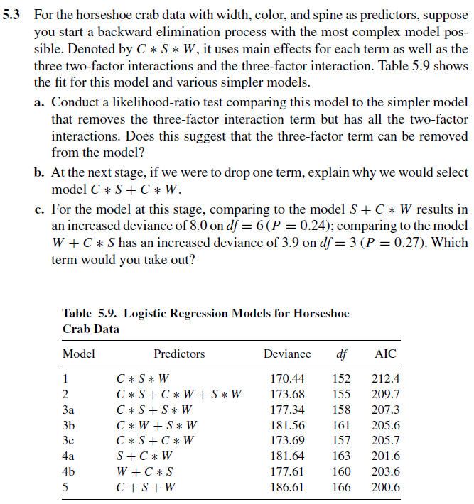 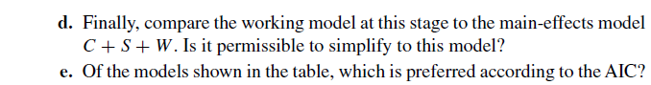

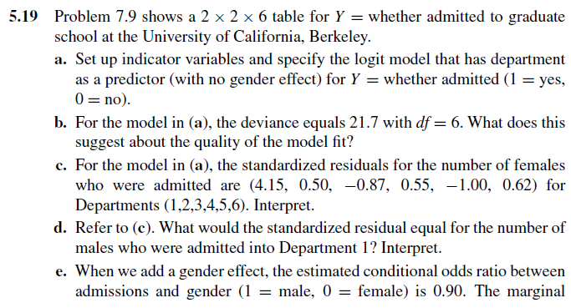 

**Part(b): Hint, compare this model with saturated one, significant difference between these 2? Do you think this model fits good or poor?**

**The table below includes the data:**

